**Florida State Council for Interstate Adult**

**Offender Supervision Meeting Minutes**

**Tallahassee, FL**

**March 13, 2024**

**9:00 am – 12:00 pm**

**Council Members in Attendance:**

Joe Winkler, Pat Tuthill, Tommy Ford, Stormie Knight

**Council Members Not in Attendance:**

Michael Kraynick, Keith Perry, Adrian Soud

**Council Guests in Attendance:**

Sharon Davis, Tim Strickland, Chris Lane, Shawn Satterfield, Cory Godwin, Tom Magorrian, Angella New, Kim Howell, Becky Choquette

**Opening Comments:** Joe Winkler began meeting at 9:00 am, Becky Choquette called roll, quorum present

**Welcome,** Joe Winkler

* Joe Winkler, Assistant Secretary of Community Corrections, Chairperson for Florida’s State Council of Interstate Adult Offender Supervision

**Recap from Last Meeting,** Joe Winkler

* Teams Meeting (June 8, 2023)
* 1 motion passed at last meeting
  + Passed a motion to approve the Formsite form for reimbursements
* Reviewed that FDC would be working with Communications on a join press release of working with the Florida Sheriffs Association

**Introduction of New Council Members**, Joe Winkler

* Stormie Knight, Policy Coordinator for Policy and Budget in the Governor’s Office, replacing Tasheba Robinson
* Michael Kraynick, replacing Judge LeDee

**Council Overview**, Joe Winkler

* Reviewed statute, 6 members making up the council, goals, current fees and amount of reimbursement collected to date

**Dashboard**, Shawn Satterfield

* Sheriff’s Department complete the formsite than then comes to our Interstate Compact Unit to review for accuracy for payment, once approved it goes to Kim Howell where she enters it into MFMP and once completed it goes back the Sheriff’s Department – this creates a good audit trail

**Reasons for Reimbursement Denials**, Tim Strickland

* 147 approvals, 22 denials
* 8 were changed when reviewed and changed the wording to any warrant for compact transfer case
* Primary reason for denials is that cases were not through the Compact, were absconders or there was no documentation with the request

**Steps Taken to Message Reimbursement**, Joe Winkler

* Spoke at the Sheriffs Association Conference and provided a one-page document with a QR code to the formsite
* Sent an email to all Sheriffs on October 9, 2023
* Resent email to Sheriffs who have not used the form yet on January 3, 2024
* Individual calls – one specifically to Orange County
* Ran pilots in Regions I and II to look at jails logs and reach out to the Sheriffs Departments
* Reaching out to the Interstate Compact National Office for cases transferred out of the state of FL and back, if Sheriffs Office was involved reach out

**Reimbursement Fees & Fiscally Constrained Counties**, Joe Winkler

* Not enough money in the fiscally constrained counties to go and pick up offender for criminal mischief cases
* Possibly double the amount for the reimbursement to the following counties (see below)

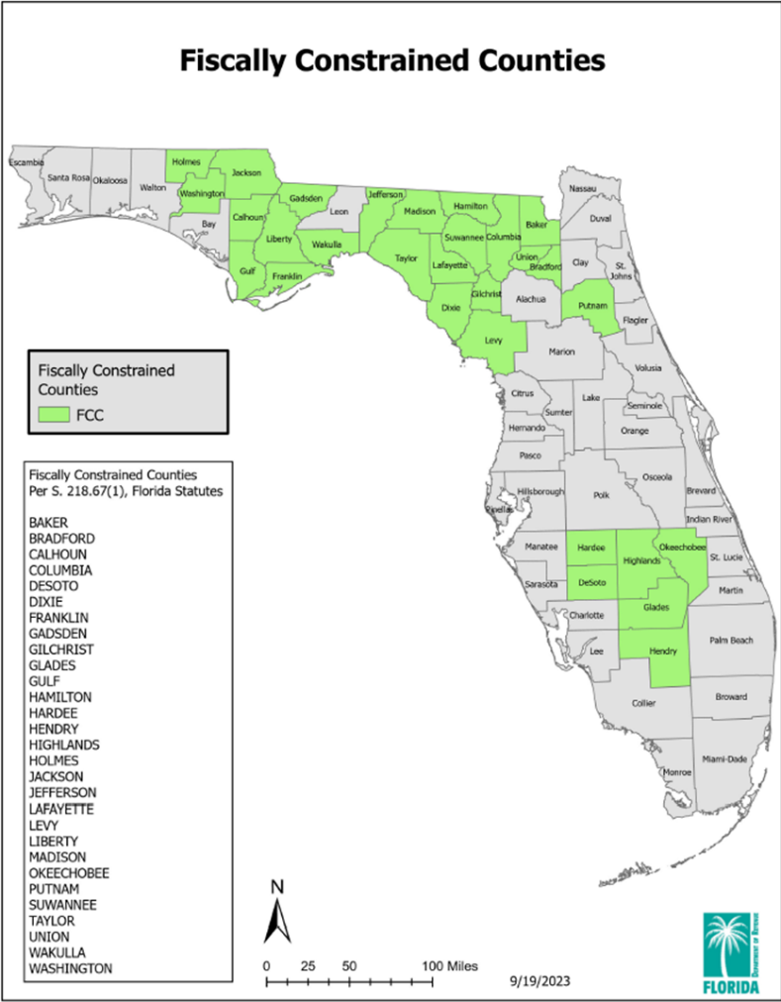

**Reimbursement Amount Exceeding Extradition Cost**, Tim Strickland

* Under the current language approved there is a flat rate
* Okaloosa county has sent a Deputy to Albany, GA that cost $100 but was reimbursed $200
* Possibly change the language

**Error Fund**, Sharon Davis

* Accounting found a few cases where the department took a little longer to set up accounts and offender made the $100 application fee but it went to court costs/victim accounts
* FDC is not allowed to move money from other accounts
* Suggestion is to wave of defer the fee, recommend paying within 6 months

**Annual Business Meeting**, Joe Winkler

* 2023 ABM – Norfolk, VA
* 2024 ABM – Scottsdale, AZ - September 9 – 11, 2024
* 2025 ABM – Possibly in Puerto Rico

**Actions Needed**

* Passed a motion to double the reimbursement fees but leave GA and AL at the current rate, effective July 1, 2024 (see below)

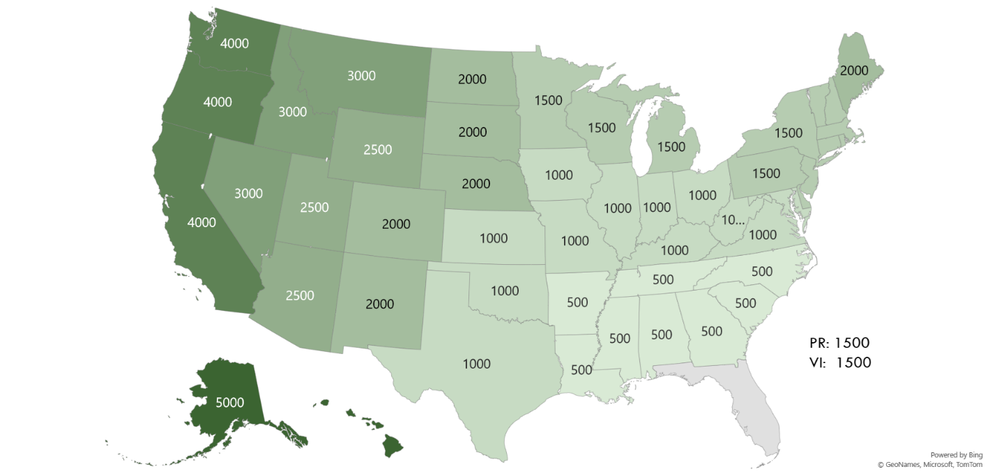

* + Passed a motion to approve reimbursement for fiscally constrained counties up to actual cost per state reimbursement guidelines or invoiced costs, effective July 1, 2024
  + Passed a motion to allow offender to defer payment if there is an error in processing made by the department, effective July 1, 2024
  + Passed a motion for the council to pay state guidelines or up to $2500 for Pat Tuthill and council members to attend the Annual Business in Scottsdale, AZ in September of 2024, including Sharon Davis and Chris Lane

**Moving Forward**, Joe Winkler

* Continue to message Sheriffs directly and with FSA
* Message from Steve Casey
* Sheriff Summit coming up, April 2 & 3, 2024 in Marion County at the Equestrian Center
* Create a tutorial that can stay on the FSA website for people to watch and learn or go back and remember
* Post the one-page flyer with QR code on the FSA website – highlight for Interstate Compact extradition

**Next Meeting – Date/Location; Objectives**, Joe Winkler

* September virtually
* Discussion to see how the new processes work

PR: 1500

VI: 1500

Meeting adjourned at 10:30 am